Exercise 2

AN EXAMPLE OF USING S-DES ALGORITHM

Plaintext (8 bits = 1 byte)

Key (10 bits)

Bit’s operations
- permutation P10:
(3 5 2 7 4 10 1 9 8 6)
- LS-1 = left shift by 1 for each of 5 bit block separately
(5 2 7 4 3 1 9 8 6 10)
- Reducing permutation P8
(6 3 7 4 8 5 10 9)
- LS-2 = left shift by 2 for each of 5 bit block separately
(7 4 3 5 2 8 6 10 1 9)

GENERATING THE K1 SUBKEY: operations (A) + (B) + (C)

Operation (A)

Operation (B)

Operation (C) = subkey K1

GENERATING THE K2 SUBKEY: operations (A) + (B) + (D) + (C)

Operation (A)

Operation (B)

Operation (D)

Operation (C) = subkey K2

ENCRYPTION

- operation IP (initial permutation) on the plaintext
2  2 6 3 1 4 8 5 7  2 6 3 1 4 8 5 7  2 6 3 1 4 8 5 7  2 6 3 1 4 8 5 7  2 6 3 1 4 8 5 7  2 6 3 1 4 8 5 7  2 6 3 1 4 8 5 7 | 6 | 3 | 1 | 4 | 8 | 5 | 7

(2) function F_{Key1}() = (() XOR f(, Key1), ())

but f(, Key1) means:

(A’) operation E/P8 (extending permutation) on the first argument of function f
4 | 1 | 2 | 3 | 2 | 3 | 4 | 1
(B’) operation (A’) ⊕ Key1 (XOR)

(C’) Convert consecutive pairs of bits to decimal numbers. The first pair read as a decimal specifies the row of table S0, and the third - the row of table S1. The second and fourth binary pairs analogously determine the column number of tables S0 and S1, respectively. The decimal numbers read from the tables are again converted to binary notation, obtaining a sequence of 4 bits.

Example: we enter (C ') with the bit string 00011100, which converted to decimal numbers give 0, 1 for S0 and 3, 0 for S1. The output produces the string shown in four yellow cells below.
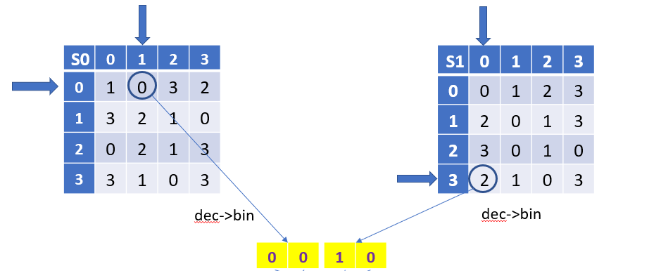

(D’) operation P4 (straight permutation)
2 | 4 | 3 | 1

F_{Key1}() = (() XOR (), ())
0 | 0 | 1 | 1 | 1 | 0 | 0 | 0

(3) operation SW (switching halves)
5 | 6 | 7 | 8 | 1 | 2 | 3 | 4

(4) function F_{Key2} () = (() XOR f(, Key2), ())

but f(, Key2) means:

(A’) operation EP (extending permutation) on the first argument of function f

(B’) operation (A’) ⊕ Key2 (XOR)

(C’) do exactly the same as in case of Key1

(D’) operation P4 (straight permutation)
2 | 4 | 3 | 1

F_{Key2}() = (() XOR (), ())

(5) operation IP⁻¹ (inverse permutation) = ciphertext

4 | 1 | 3 | 5 | 7 | 2 | 8 | 6

